How to Save YouTube Videos to Your Own Computer
There are many ways of capturing video from the Internet and saving it on your computer. I’ve read through many different options by searching for “capture streaming video” in a search engine, like Google.
The simplest way that I have found to capture, or save, YouTube videos is to use the web-based Keepvid.com. “Web-based” means that you don’t have to download anything to your computer. Here are five simple steps to save a video from YouTube.
- Find the video that you want to save on YouTube and copy the YouTube address.
- Go to www.keepvid.com. Paste the address in the blue box with the letters “URL”. You can choose the quality that you want to save the clip as. I suggest MP4, High Quality.
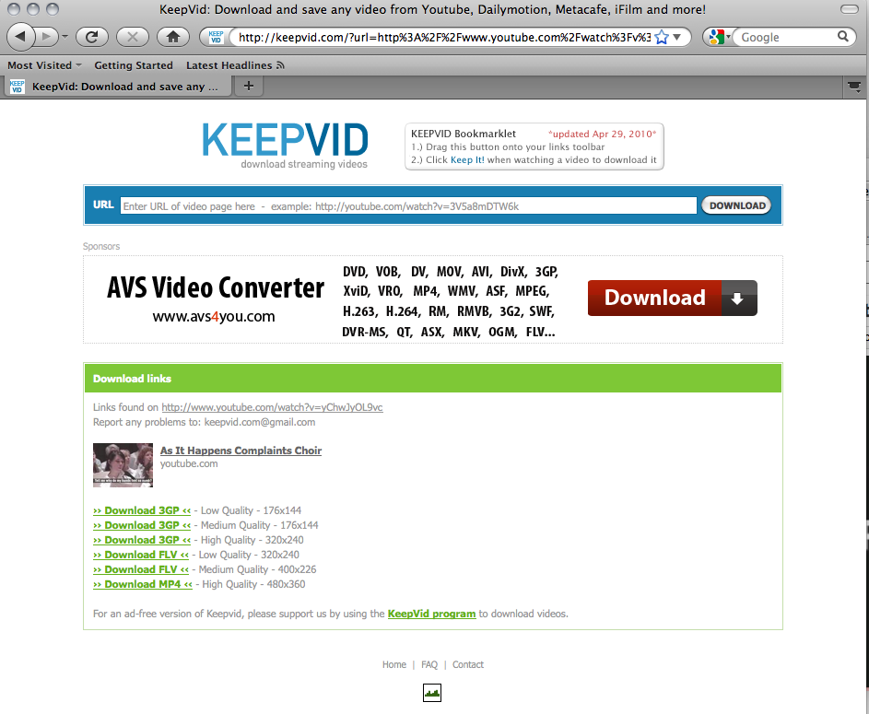
- The file will most likely be saved in your download folder. You will be able to play it on

For a video of a similar process using www.savevid.com, go to Jammie Keddie’s video http://www.youtube.com/watch?v=umjfEzDgeKE A discussion on “To download or not to download” go to http://www.jamiekeddie.com/ For ideas of how to use video clips to teach English, go to http://www.teflclips.com/ Yet another web-based option to download YouTube videos is http://vixy.net

